Movie Recommendation System
What is movie recommendation system ?
A movie recommendation system is a fancy way to describe a process that tries to predict your preferred items based on your or people similar to you.
In layman’s terms, we can say that a Recommendation System is a tool designed to predict/filter the items as per the user’s behavior.
Types of Recommendation Systems:

* content Based: depends on content similarity.
* collaborative: filtering based(depends on user interests).
* hybrid based: both content and collaborative based.

We used content based similarity for this recommendation system.
The process followed in the movie recommendation system
- Preparing data set - that contains required fields need with less no.of null values
- Preprocessing data -removing null values
- Model development and implementation.

How to build a Movie Recommendation System using Machine Learning
The approach to build the movie recommendation engine consists of the following steps.
- Perform Exploratory Data Analysis (EDA) on the data
- Build the recommendation system
- Get recommendations

Step 1: Perform Exploratory Data Analysis (EDA) on the data
The dataset contains two CSV files, credits, and movies. The credits file contains all the meta data information about the movie and the movie file contains the information like name and id of the movie, budget, languages in the movie that has been released, etc.

Step 2: Build the Movie Recommender System
The accuracy of predictions made by the recommendation system can be personalized using the “plot/description” of the movie.
But the quality of suggestions can be further improved using the metadata of movie. Let’s say the query to our movie recommendation engine is “The Dark Knight Rises”. Then the predictions should also include movies directed by the director of the film. It should also include movies with the cast of the given query movie.

Step 3: Get recommendations for the movies
The get_recommendations() function takes the title of the movie and the similarity function as input. It follows the below steps to make recommendations.
- Get the index of the movie using the title.
- Get the list of similarity scores of the movies concerning all the movies.
- Enumerate them (create tuples) with the first element being the index and the second element is the cosine similarity score.
- Sort the list of tuples in descending order based on the similarity score.
Analysis of the movie recommendations system
We import numpy and pandas libraries to work with linear algebra and dataset.
import numpy as np
import pandas as pd
- Read the movie data set file into Jupyter notebook.
movies = pd.read_csv('tmdb_5000_movies.csv')
credits = pd.read_csv('tmdb_5000_credits.csv')
- Since there are two files we merge them, as it is easy to use. These data set can be merge using both title and Id.
- Since there are so many columns that are present in the dataset only needed columns are taken
- movies = movies[['title','overview','genres','keywords','cast','crew']]
Only the need columns are taken.
- To find the columns which has null values movies.isnull().sum() is used.
Since in the data the null values are very less dropna() function is used.

Most of the dataset are in dictionary with different types of data in it. But only one type of data is needed so to extract the data function is written but to extract the names because the indices are not integers
- So ast is imported and literal_eval is used The all the needed keywords are extracted from every column.
- Cast and crew has different ways to extract as only top three are needed in the cast so lambd function to take only top three values. In crew only director is needed since some people watch as the director directed the movie.
- Transformation is used on the keyword, genre, cast, crew to remove the spaces between the words as it will confuse the system.
Overview is the summary of the movie it contains many keywords which are used for the recommendations so we split them into single words by remove the stopword!
Movie Dataset:
- title: Movie Title.
- Overview: Abstract of the Movie.
- Popularity: Movie popularity rating as per TMDB.
- Vote_average: Votes average out of 10.
- Vote_count: Number of votes from the users.
- Release_date: Date of release of the movie.
- Keywords: Keywords for the movie by TMDB in the list.
- Genres: Movie Genres in the list.
- Cast: Cast of the movie on the list.
- Crew: Crew of the movie in the list.
VECTORIZATION:
In this we use bag of words technique.here movies consider as vectors.
- Steps used for vectorization process:
- Combined tags of the movies.
- Take the most repeated words more than 5000 words.
- Calculate frequency of each word.
- From sklearn countvectoriz class is used it produces “spicy sparse matrix” so we converted into numpy array.
- Then we apply stimming process by using NLTK which is “natural language processing library”.
Here we use cosine distance which takes theta to find the similarity between two vectors as euclidain distance not a reliable method for higher dimensions

When the cosine similarity is nearer 1 then there are more similar else when it is near zero the dissimilar.
The steps involved in recommending model
- Find the index of the user given movie
- Finding the similarity
- First five similar movies are need
- Sort the similarities enumerate is used so that the movie title can be linked.
- Recommend the top similar movies.

These are the steps involved in the construction of movie recommendation model and this model can be used for any type of the recommendation system.

By adding the tag lines to the considerable dataset ,the predicted values will change this happen due to because of adding unnecessary feature which may deviate the original value of the predicted dataset.

movies = movies[['title','overview','genres','keywords','cast','crew','tagline']]

this brings a drastic change to the dataset and only the movies having the same tagline will be recommended but not with the other movies.

So adding more unnecessary features will not bring accurate result.

movies.genres.value_counts().plot.pie()

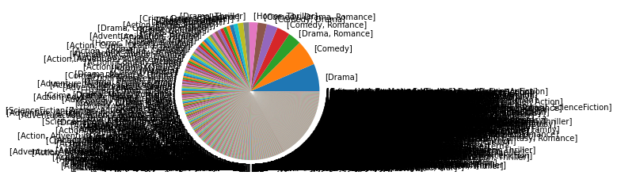

movies.genres.value_counts().plot.hist()

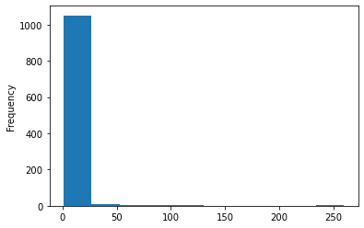

Yours Sincerely,
ID:s180313,
ID:s180316,
Cse-2E.

